
Head Injury
Prevention of Head Injuries in Children
A
Head injury is defined as any form of injury or trauma to the skull, scalp or the brain. The head injury ranges from a small or mild bruise or bump in the head to a traumatic or serious brain injury. Some of the common examples of head injury include; scalp wounds, fractures in the skull and concussions. Different treatment methods are used for treating the conditions depending on the severity of the injury or the cause of the head injury.


Children Head Injury in Schools
Studies have indicated that children, especially the school going children, are at an increased risk of having head injuries. This is mainly because of the children’s increased physical activities and other potential risks within the school setting. The potential risks for a brain injury within a school setting include:
- Accidents – children can suffer devastating injuries from accidents at school. The accident injuries can be caused from school bus accidents, slip and fall accidents within the school, playground accidents and accidents due to sporting activities. The injuries from these accidents can lead to serious head injuries within the school.
- Assault and bullying is also another potential risk for head injury in a school setting. There are reported cases where children have been reportedly bullied or assaulted by other learners in the school setting and they suffer devastating injuries. The injuries can be caused on the head causing head injuries.
- Traffic accidents form a potential risk for children who are at school. Crossing the roads or using the school vans or buses can cause a head injury for the children.
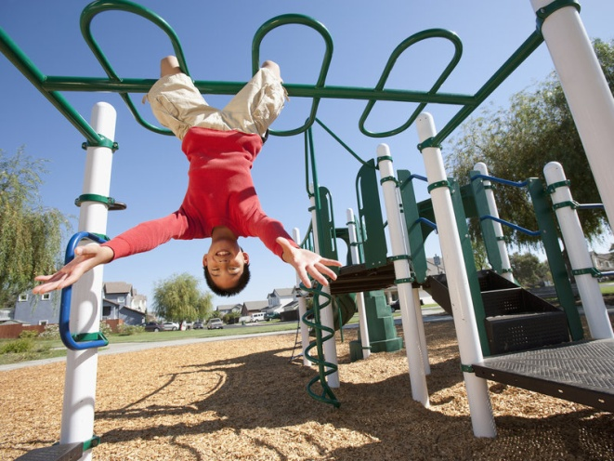

Who to Contact in Case of Head Injury?
Severe head injuries require one to have immediate medical attention. To receive medical attention, one can contact the following:
- Contact the school medical department
- Call 911 for emergency medical assistance.

Learning Resources
Centers for Disease Control and Prevention. (2020). HEADS UP to Schools: Resources for School Nurses. [online] Available at: https://www.cdc.gov/headsup/schools/nurses.html [Accessed 13 Feb. 2020].
Trefan, L., Houston, R., Pearson, G., Edwards, R., Hyde, P., Maconochie, I., ... & Kemp, A. (2016). Epidemiology of children with head injury: a national overview. Archives of disease in childhood, 101(6), 527-532.
How to Prevent Head Injury in School
Different steps can be used to help prevent children from suffering head injury in a school setting. The steps include;
- Ensuring that the playground surfaces are properly covered with a layer of shock absorbing material so that the children cannot be injured in case they fall.
- Using seat belts in the school buses or fans to avoid any severe injury to the head of the children in case there is an accident.
- Teachers need to ensure that children are properly monitored when they are in school so that they cannot be involved in accidents such as falls which will cause head injury.

- Teachers and school administrators need to pass strict rules against bullying and other forms of assault by other children so as to avoid any form of injury.
- The teachers need to properly talk with the children about the issue of head injury, it effects and the different ways that they can avoid it.
- Teachers need to make sure that children who are involved in sports wear protective gear so that any accidents which might occur do not cause any injuries on the head.

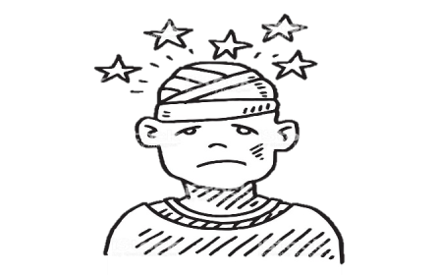
What to Do in The Case of a Head Injury
In case of a head injury, the following steps need to be done:
- If there is any form of bleeding, it should be stopped using a clean piece of cloth.
- Breathing needs to be checked and if necessary, rescue breathing needs to be started.
- The swollen areas need to be pressed with the ice packs.
- Emergency medical practitioners need to be called immediately if the condition worsens.

